Village of Vesper

Trash and Recycling Collection Schedule
Trash will be collected every Friday.
Recycling will be collected every other Friday.
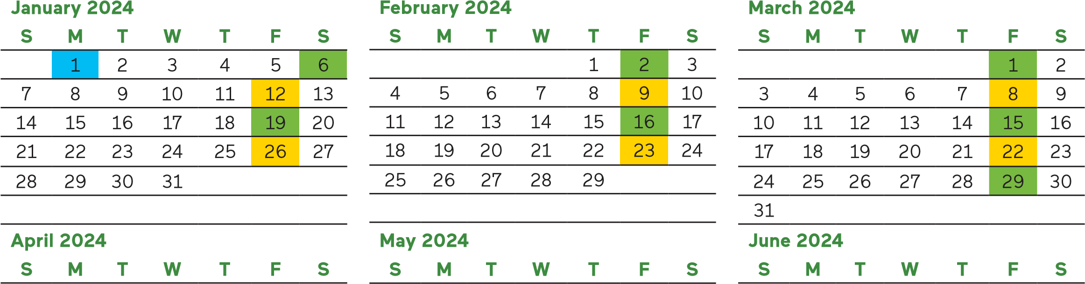
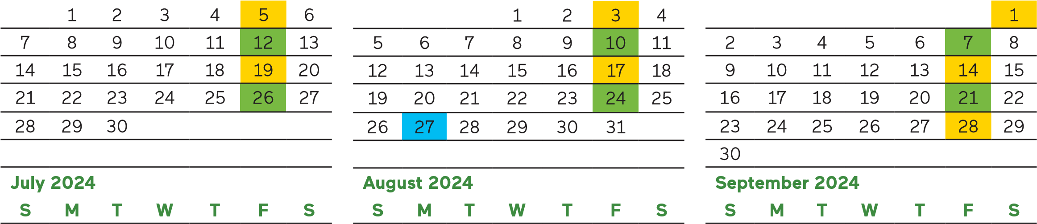
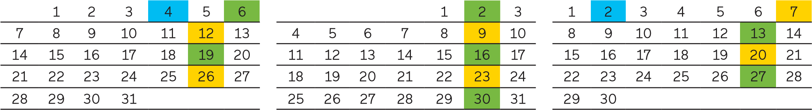
Trash Only Collection Trash and Recycling Collection Observed Holiday
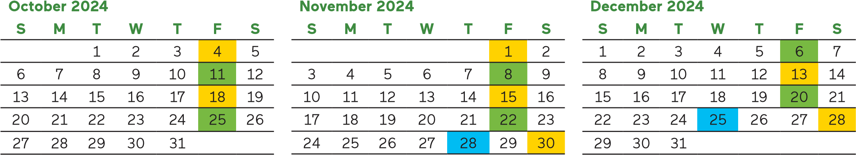
Observed Holidays
Please note, if your service day falls on or follows one of these observed holidays, your service will be delayed by one day for that week only. Carts must be curbside by 5 a.m. and be fully accessible with 3 to 4 feet of clearance around each cart. Cannot be blocked by parked vehicles.
New Year’s Day: Monday January 1, 2024 Labor Day: Monday September 2, 2024
Memorial Day: Monday May 27, 2024 Thanksgiving Day: Thursday November 28, 2024 Independence Day: Thursday July 4, 2024 Christmas Day: Wednesday December 25, 2024
Customer Service Chat:wm.com
My WM: Manage your services with a My WM account. Visit wm.com/mywm to create an account. Email: wmservice@wm.com
© 2024 WM Intellectual Property Holdings, LLC

